DATA ANALYTICS PROJECT

India Agriculture Crop Production Analysis

Team Members:

Sweta Chandrasekhar-20BCE2625

Mohamed Zaid-20BCE2589

Kp.Shashaank-20BCE2428

A.Jaswanthi-20BCE2826

**Introduction:**

India has a rich agricultural heritage and is one of the world's largest producers of various crops. Analyzing the crop production data from 1971 to 2021 provides valuable insights into the dynamics, trends, and challenges of India's agriculture sector over five decades. This analysis aims to understand the patterns of crop production, evaluate the factors influencing production levels, and assess the impact on farmers, the economy, and food security.

The agricultural sector in India plays a crucial role in providing livelihoods to millions of people, contributing to the country's GDP, and ensuring food security for a vast population. Crop production analysis helps policymakers, researchers, and stakeholders make informed decisions and design effective strategies to enhance agricultural productivity, sustainability, and rural development.

The period from 1971 to 2021 witnessed significant changes in India's agricultural landscape, marked by technological advancements, policy interventions, and climate change impacts. Analyzing the historical trends, crop yields, and production data allows us to identify the driving forces behind changes in crop production, understand the challenges faced by farmers, and explore opportunities for growth and resilience.

This analysis will delve into various aspects, including crop-specific production trends, factors influencing yield variations, climate change impacts, technological advancements, government policies, market dynamics, and socio-economic implications. By examining these factors, we can gain a comprehensive understanding of the agricultural sector's evolution and identify areas for improvement and intervention.

The insights derived from this analysis can support evidence-based decision-making, policy formulation, and the development of sustainable agricultural practices. Additionally, it can help stakeholders identify opportunities for market growth, investment, and innovation in the agriculture sector.

By analyzing India's agriculture crop production from 1971 to 2021, we aim to contribute to the body of knowledge surrounding the challenges and opportunities in Indian agriculture, ultimately fostering the growth and sustainability of the sector and improving the lives of farmers and rural communities.

**FLOWCHART:**

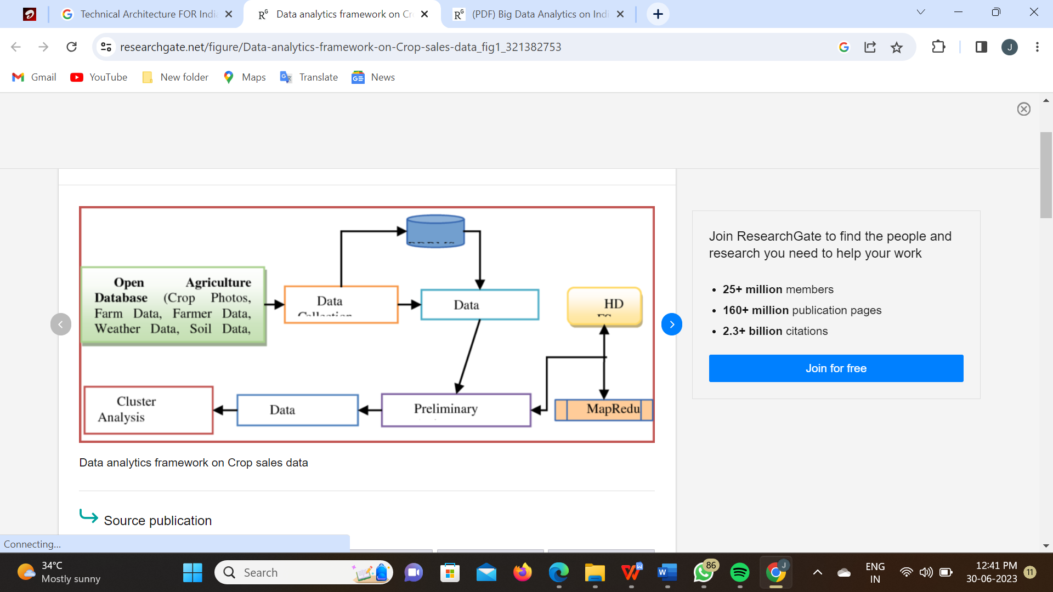

**Project Flow:**

Analyzing the flow of agricultural crop production in India involves understanding the key stages and factors that contribute to the overall process. Here's a general outline of the project flow for analyzing crop production in India:

* Data Collection:

Gather relevant data on crop production from reliable sources such as government agricultural departments, research institutions, and agricultural surveys.

Obtain data on factors influencing crop production, including climate, soil quality, irrigation, fertilizers, pesticides, and agricultural practices.

* Crop Selection:

Identify the major crops cultivated in different regions of India.

Determine the criteria for selecting specific crops for analysis, such as economic significance, yield, area under cultivation, and regional variations.

* Regional Analysis:

Divide India into different regions based on agro-climatic zones or state-wise divisions.Analyze the agricultural patterns, crop preferences, and crop rotations specific to each region.Consider the impact of regional variations in climate, soil type, water availability, and farming practices on crop production.

* Historical Trends:

Analyze historical data on crop production, including yield, area under cultivation, and production volume over a significant time period.

Identify long-term trends, seasonal variations, and the impact of external factors such as policy changes, technological advancements, and climate variations.

* Statistical Analysis:

Apply statistical methods to the collected data to identify patterns, correlations, and trends in crop production.

Conduct regression analysis to understand the relationship between crop production and factors such as rainfall, temperature, irrigation, fertilizers, etc.

Use tools like Excel, R, or Python for data analysis and visualization.

* Factor Analysis:

Identify and evaluate the key factors influencing crop production in India.

Examine the impact of factors such as climate change, water scarcity, land availability, government policies, subsidies, market conditions, and technological interventions.

Assess the role of agricultural practices, including organic farming, crop rotation, intercropping, and use of genetically modified crops.

* Comparative Analysis:

Compare crop production trends across different regions, states, and crops.

Evaluate the performance of different crops in terms of yield, profitability, and sustainability.

Identify successful agricultural models and best practices employed in specific regions or states.

Recommendations and Policy Implications:

Based on the analysis, provide recommendations for improving crop production in India.

Suggest policy interventions, technological advancements, and sustainable practices to enhance agricultural productivity, reduce input costs, and mitigate risks.

Consider the socio-economic and environmental implications of the recommendations.

* Reporting and Communication:

Prepare a comprehensive report summarizing the analysis, findings, and recommendations.

Present the results to stakeholders such as government agencies, agricultural experts, farmers' associations, and policymakers.

Use visualizations, charts, and graphs to effectively communicate the analysis outcomes.

Remember, this is a generalized flow for analyzing crop production in India, and the actual process may vary depending on the scope, objectives, and available data for your specific project.

**Problem Understanding:**

**Historical Crop Production Trends:**

Analyze the historical trends and patterns of crop production in India over the specified period.

Identify crops that have exhibited significant changes in production levels, both in terms of quantity and quality.

Determine the factors influencing these trends, including technological advancements, changes in agricultural practices, policy interventions, and market dynamics.

**Crop Yield and Productivity:**

Evaluate the crop yield and productivity for major agricultural crops in India during the analyzed period.

Assess the variations in yield across different regions, states, and crops.

Understand the factors contributing to differences in yield, such as climate, soil quality, irrigation, fertilizers, pest management, and adoption of modern agricultural practices.

**Climate Change Impact:**

Examine the impact of climate change on crop production in India.

Analyze the changes in temperature, rainfall patterns, and extreme weather events and their effects on crop yields.

Identify the vulnerability of different crops to climate change and the adaptation strategies employed by farmers.

**Technological Advancements and Adoption:**

Study the adoption of new technologies and innovations in Indian agriculture during the analyzed period.

Evaluate the impact of technological advancements, such as improved seeds, irrigation systems, mechanization, and precision agriculture techniques, on crop production.

Identify the rate of technology adoption and assess the barriers or challenges faced by farmers in adopting new agricultural practices.

**Government Policies and Interventions:**

Understand the influence of government policies and interventions on crop production in India.

Evaluate the effectiveness of policies related to agricultural subsidies, credit availability, price support mechanisms, and market reforms.

Analyze the impact of policy changes on crop production, farmer incomes, and market stability.

**Market Dynamics and Price Volatility:**

Examine the market dynamics and price volatility of agricultural commodities during the analyzed period.

Identify the factors influencing price fluctuations, including demand-supply dynamics, market infrastructure, trade policies, and global market trends.

Assess the impact of price volatility on farmer incomes, profitability, and decision-making.

**Sustainability and Environmental Considerations:**

Evaluate the sustainability of agricultural practices during the analyzed period.

Assess the use of fertilizers, pesticides, and water resources and their environmental implications.

Identify the adoption of sustainable practices, such as organic farming, conservation agriculture, and crop diversification, and their impact on crop production and environmental sustainability.

**Socio-Economic Impact:**

Examine the socio-economic impact of crop production on farmers and rural communities.

Assess the income levels, livelihoods, and welfare of farmers engaged in crop production.

Evaluate the distribution of benefits and the inclusivity of agricultural development initiatives.

Business Problem

**Long-term Crop Yield Analysis:**

Determine the historical trends and patterns in crop yields for major agricultural crops in India over the specified period.

Identify the crops that have shown significant improvements or declines in yield.

Understand the factors influencing these trends, such as changes in agricultural practices, technological advancements, climate variations, and policy interventions.

Assess the impact of crop yield changes on the profitability and sustainability of farming operations.

**Regional Disparities and Crop Performance:**

Analyze regional disparities in crop production and yield across different states and agro-climatic zones in India.

Identify regions that have consistently outperformed others in terms of crop production and yield.

Investigate the factors contributing to the success of these regions, such as favorable climatic conditions, irrigation facilities, soil quality, adoption of improved agricultural practices, or government support.

Determine the reasons behind poor crop performance in specific regions and suggest measures to address the challenges.

**Crop Diversification and Market Potential:**

Evaluate the trends in crop diversification in India over the specified period.

Identify the crops that have gained prominence and those that have declined in cultivation.

Assess the market potential and profitability of different crops based on historical price trends, domestic demand, export opportunities, and government policies.

Analyze the impact of crop diversification on farmers' income, market stability, and food security.

**Climate Change Resilience:**

Examine the impact of climate change on crop production in India and its implications for the agricultural sector.

Identify crops that have shown resilience to climate change effects and those that are more susceptible.

Evaluate the adaptation measures adopted by farmers and the effectiveness of these strategies in mitigating climate-related risks.

Suggest climate-resilient agricultural practices, crop selection strategies, and policy interventions to enhance the sector's resilience to climate change.

**Technology Adoption and Productivity:**

Analyze the adoption of modern agricultural technologies and their impact on crop productivity.

Evaluate the penetration of mechanization, irrigation systems, genetically modified crops, precision agriculture techniques, and other technological advancements.

Assess the relationship between technology adoption, input costs, and crop yields.

Identify barriers to technology adoption and provide recommendations for promoting the adoption of sustainable and cost-effective agricultural technologies.

**Policy Evaluation and Recommendations:**

Evaluate the effectiveness of past agricultural policies and interventions in promoting crop production, sustainability, and farmers' welfare.

Assess the impact of policy changes, subsidies, agricultural credit facilities, and market reforms on crop production.

Provide recommendations for policy improvements, including targeted interventions, incentives for sustainable farming practices, market reforms, and support mechanisms for smallholder farmers.

**Business Requirements:**

**Comprehensive Historical Data:**

Obtain reliable and comprehensive historical data on crop production, yield, area under cultivation, and other relevant factors from 1971 to 2021.

Gather data at the national, regional, and state levels to enable detailed analysis.

Ensure the data includes information on major agricultural crops cultivated in India during this period.

**Data Cleaning and Integration:**

Clean and preprocess the collected data to remove any inconsistencies, errors, or missing values.

Integrate and standardize the data from various sources to create a unified dataset for analysis.

Ensure the dataset is structured and well-organized for efficient analysis.

**Climate and Weather Data:**

Gather historical climate and weather data for different regions of India during the specified period.

Include variables such as rainfall, temperature, humidity, and other climatic factors that impact crop production.

Integrate the climate data with the crop production data for analyzing the relationship between climate variables and crop yields.

**Socio-Economic Data:**

Collect relevant socio-economic data that influences agricultural production, such as population demographics, income levels, agricultural workforce, and rural development indicators.

Include data on government policies, subsidies, agricultural infrastructure, and market conditions.

Analyze the socio-economic factors alongside crop production data to understand their impact on agricultural outcomes.

**Analysis Tools and Software:**

Identify suitable analytical tools and software for data analysis, such as statistical analysis software (e.g., R, Python, or specialized agricultural software).

Ensure the selected tools have capabilities for data exploration, visualization, regression analysis, and trend identification.

Consider the availability of machine learning or predictive modeling capabilities for advanced analysis if required.

**Statistical Analysis and Modeling:**

Apply statistical techniques to analyze the historical crop production data and identify trends, patterns, and correlations.

Conduct regression analysis to understand the relationship between crop yields and various factors such as climate, soil quality, technology adoption, and policy changes.

Consider employing predictive modeling techniques to forecast crop production based on historical data and external factors.

**Data Visualization and Reporting:**

Create clear and visually appealing data visualizations, including charts, graphs, and maps, to effectively communicate the analysis outcomes.

Generate comprehensive reports summarizing the analysis findings, trends, and insights.

Present the analysis results in a format suitable for decision-makers, policymakers, and stakeholders.

**Recommendations and Actionable Insights:**

Derive actionable insights and recommendations from the analysis to improve crop production in India.

Provide specific strategies, interventions, and policy recommendations based on the analysis outcomes.

Highlight the potential impact of suggested measures on crop productivity, sustainability, and farmers' welfare.

**Literature Survey:**

Analyzing the entire literature on Indian crop production is an extensive task, given the vast amount of research conducted in this field. However, I can provide you with a brief literature survey on Indian crop production, highlighting some key studies and trends. Please note that the information provided is based on research available up until September 2021, and there may have been new developments since then.

1. "Agricultural Productivity in India: Trends, Patterns, and Determinants" by Gulati et al. (2009): This study examines the trends and determinants of agricultural productivity in India, focusing on crop production. It provides insights into the factors influencing crop yields and identifies areas for improvement.

2. "Recent Trends in Indian Agriculture: A State-Wise Analysis" by Kumar and Swamy (2017): This research analyzes the recent trends in Indian agriculture at the state level, including crop production. It discusses the variations in crop productivity and highlights the factors contributing to these differences among states.

3. "Impact of Climate Change on Indian Agriculture: A Review" by Jat et al. (2014): This review paper discusses the potential impacts of climate change on Indian agriculture, including crop production. It examines the challenges posed by changing climatic conditions and suggests adaptation strategies to mitigate the adverse effects.

4. "Technology, Economic Growth, and Regional Disparities in Indian Agriculture" by Pal and Ghosh (2018): This study investigates the role of technology adoption in crop production and its impact on regional disparities in Indian agriculture. It analyzes the relationship between technological advancements, economic growth, and crop yields.

5. "Crop Diversification in India: Determinants and Effects" by Birthal et al. (2015): This research focuses on crop diversification in India, exploring the determinants of crop choices and its effects on productivity and income. It sheds light on the potential benefits of diversifying agricultural practices and reducing dependence on specific crops.

6. "Efficiency and Productivity of Indian Agriculture: A State-Level Analysis" by Bhattacharyya et al. (2019): This study assesses the efficiency and productivity of Indian agriculture at the state level, considering various crops. It examines the factors influencing agricultural performance and provides insights into strategies for enhancing productivity.

7. "Sustainable Agricultural Practices in India: Constraints and Opportunities" by Mishra et al. (2016): This paper discusses sustainable agricultural practices in India, with a focus on crop production. It identifies the constraints faced by farmers in adopting sustainable practices and explores potential opportunities to promote sustainable agriculture.

These studies represent a small fraction of the vast literature available on Indian crop production. Conducting a comprehensive literature survey would require a systematic review of numerous research articles, reports, and publications across multiple disciplines. To delve deeper into this topic, I recommend consulting academic databases, research journals, and agricultural institutions in India, such as the Indian Council of Agricultural Research (ICAR), National Institute of Agricultural Economics and Policy Research (NIAP), and Indian Agricultural Research Institute (IARI), among others.

**Social or Business Impact:**

**Social Impact:**

Food Security: Understanding crop production trends, yield variations, and factors influencing production can contribute to ensuring food security in India. By identifying crops that have shown significant improvements in production, policymakers can focus on promoting those crops to meet the growing demand for food.

Livelihoods of Farmers: Analyzing crop production can provide insights into the income and livelihoods of farmers. By understanding the factors affecting crop yields and productivity, targeted interventions and support can be designed to improve farmers' incomes and well-being.

Rural Development: Agriculture is a major source of employment and economic activity in rural areas. Analyzing crop production can inform policies and initiatives aimed at rural development, including investments in infrastructure, irrigation facilities, and agricultural extension services.

Sustainable Agriculture: Examining the sustainability of agricultural practices can have a positive impact on the environment and natural resources. Promoting sustainable practices such as organic farming, water conservation, and soil management can enhance long-term agricultural productivity while minimizing negative environmental consequences.

Climate Change Resilience: Assessing the impact of climate change on crop production and identifying climate-resilient crops and adaptation strategies can help farmers and communities mitigate risks associated with changing climatic conditions. This can contribute to building resilience in the agricultural sector and reducing vulnerability to climate-related shocks.

**Business Impact:**

Market Opportunities: Analyzing crop production can identify crops with high market potential and demand. This information can help businesses in the agriculture sector, including seed companies, agrochemical manufacturers, and food processing industries, make informed decisions regarding crop selection, investment, and market expansion.

Investment Decisions: Understanding historical crop production trends, technological advancements, and policy changes can guide investment decisions in the agriculture sector. This includes investments in research and development, technology adoption, infrastructure, and supply chain development.

Risk Management: Crop production analysis can assist businesses in assessing and managing risks associated with agricultural commodities. By understanding production patterns and factors influencing crop yields, businesses can develop risk management strategies, including hedging, supply chain diversification, and inventory management.

Value Chain Optimization: Crop production analysis can identify inefficiencies and bottlenecks within the agricultural value chain. Businesses can use this information to optimize processes, improve logistics, and enhance collaboration among stakeholders, leading to cost savings and improved market competitiveness.

Market Intelligence: Analyzing crop production data can provide businesses with valuable market intelligence, including price trends, supply-demand dynamics, and consumer preferences. This information can help businesses make informed decisions related to pricing, product development, market segmentation, and distribution strategies.

**Data Collection & Extraction From Database:**

**Identify Data Sources:**

Determine the relevant sources for obtaining the required data on crop production, yield, and other related variables. These sources may include government agencies, agricultural departments, research institutions, and international organizations.

Common data sources for India's agriculture include the Ministry of Agriculture and Farmers' Welfare, Indian Council of Agricultural Research (ICAR), National Sample Survey Office (NSSO), and the Food and Agriculture Organization (FAO).

**Access Official Databases:**

Visit the websites of relevant government agencies or organizations to access their official databases or data portals.

Check if the data is available for free or if there are any restrictions or registration requirements for accessing the data.

**Data Variables and Granularity:**

Identify the specific variables you need for your analysis, such as crop production quantity, crop yield, area under cultivation, and other relevant factors like rainfall and temperature.

Determine the desired level of granularity, such as national, state-wise, or district-wise data, based on the scope of your analysis.

**Data Extraction Methods:**

Explore the available options for extracting the required data. This may include downloading data files in CSV or Excel format, accessing APIs, or utilizing data extraction tools.

Some databases may provide direct download options, while others may require data extraction through programming languages like Python or R using web scraping techniques or APIs.

**Data Preprocessing and Cleaning:**

Once you have obtained the data, perform data preprocessing and cleaning to ensure its quality and usability.

Remove any duplicate records, handle missing values, standardize data formats, and address any inconsistencies or errors in the dataset.

**Data Integration and Merging:**

If you need data from multiple sources, merge and integrate the datasets into a unified dataset.

Ensure that the datasets have common identifiers, such as crop names, geographical codes, or time periods, to facilitate merging and analysis.

**Data Validation and Quality Assurance:**

Validate the data to ensure its accuracy and reliability.

Cross-check the data with other sources, perform data quality checks, and resolve any discrepancies or anomalies that may arise.

**Store and Organize the Data:**

Store the collected and processed data in a secure and accessible location, such as a database or file system.

Organize the data in a structured manner, using appropriate file naming conventions and documentation to facilitate future analysis and sharing.

**Collect The Dataset:**

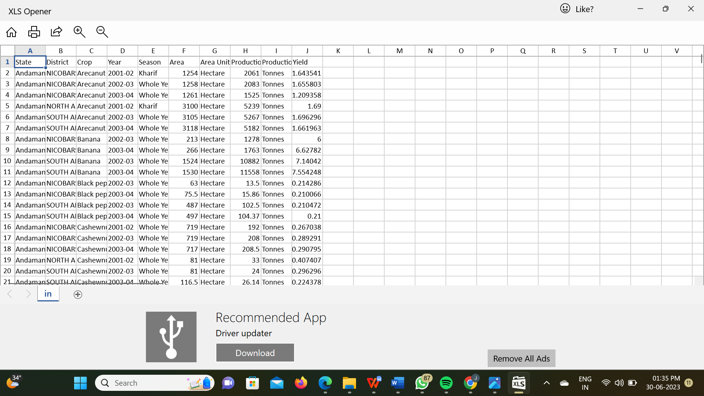

**Prepare The Data For Visualization**

Preparing the data for visualization involves cleaning the data to remove irrelevant or missing data, transforming the data into a format that can be easily visualized, exploring the data to identify patterns and trends, filtering the data to focus on specific subsets of data, preparing the data for visualization software, and ensuring the data is accurate and complete. This process helps to make the data easily understandable and ready for creating visualizations to gain insights into the performance and efficiency.

**Data Visualization**

Data visualization is the process of creating graphical representations of data in order to help people understand and explore the information. The goal of data visualization is to make complex data sets more accessible, intuitive, and easier to interpret. By using visual elements such as charts, graphs, and maps, data visualizations can help people quickly identify patterns, trends, and outliers in the data.

**BAR CHART**

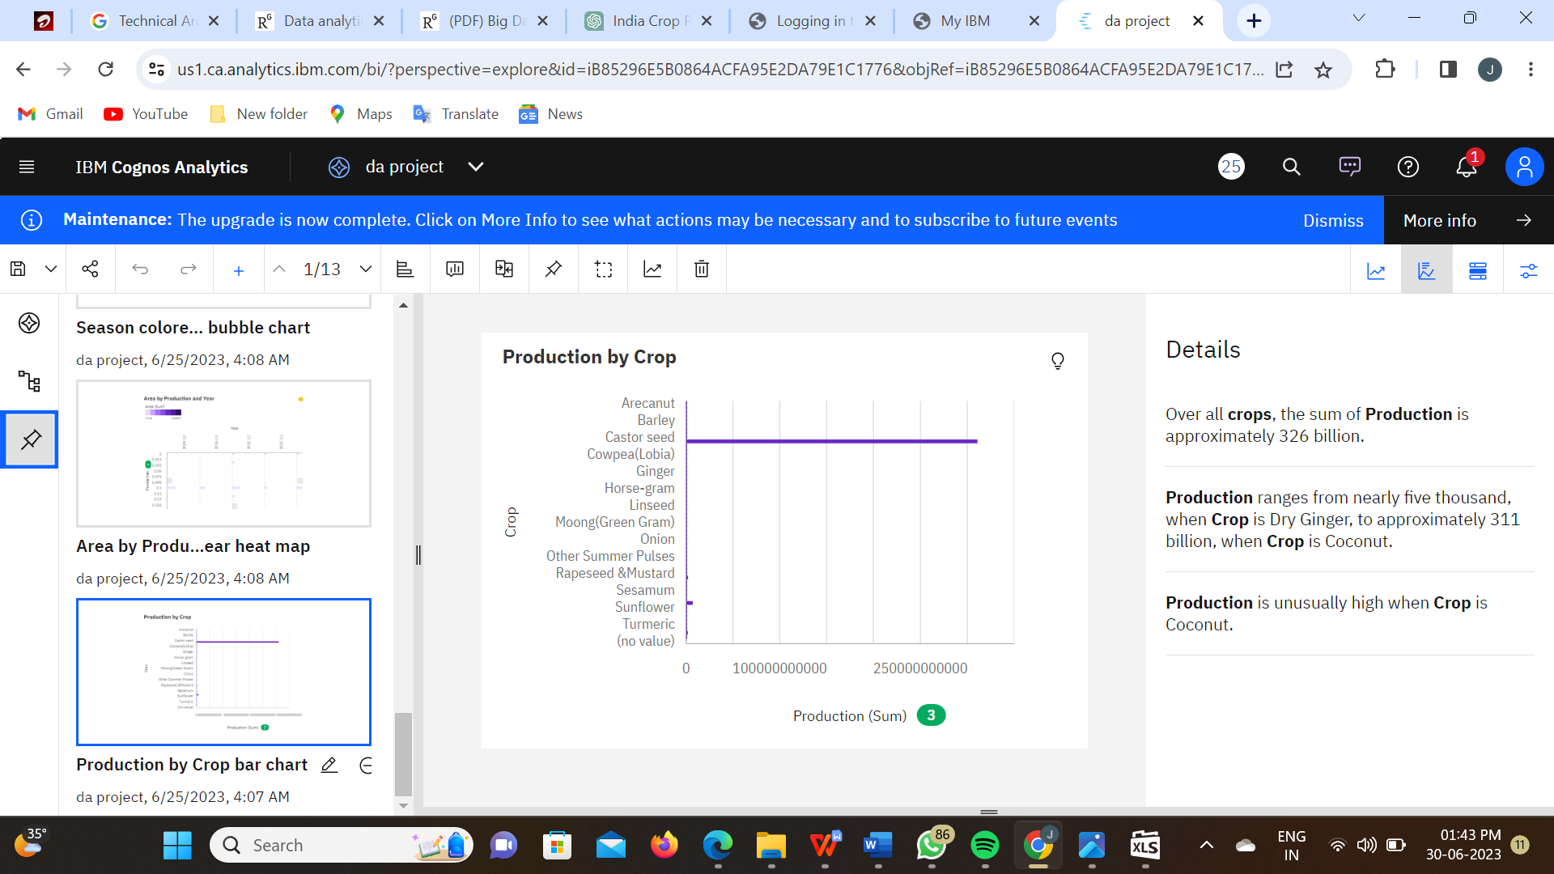

**Link for Explanation –**

[**https://drive.google.com/file/d/1mWbc4bRKrqe1BUSQ_bCCnUl5hhCyKQxD/view?usp=sharing**](https://drive.google.com/file/d/1mWbc4bRKrqe1BUSQ_bCCnUl5hhCyKQxD/view?usp=sharing)

**HEAT CHART**

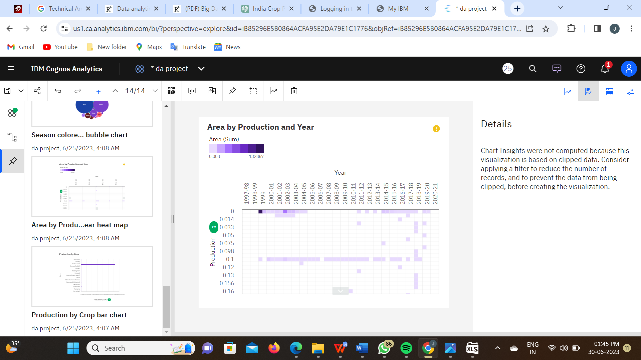

**Link for Explanation –**

[**https://drive.google.com/file/d/1LC-FFNvTZ8ntd2zFCl3D_4tzuY8U_o8E/view?usp=sharing**](https://drive.google.com/file/d/1LC-FFNvTZ8ntd2zFCl3D_4tzuY8U_o8E/view?usp=sharing)

**BUBBBLE CHART:**

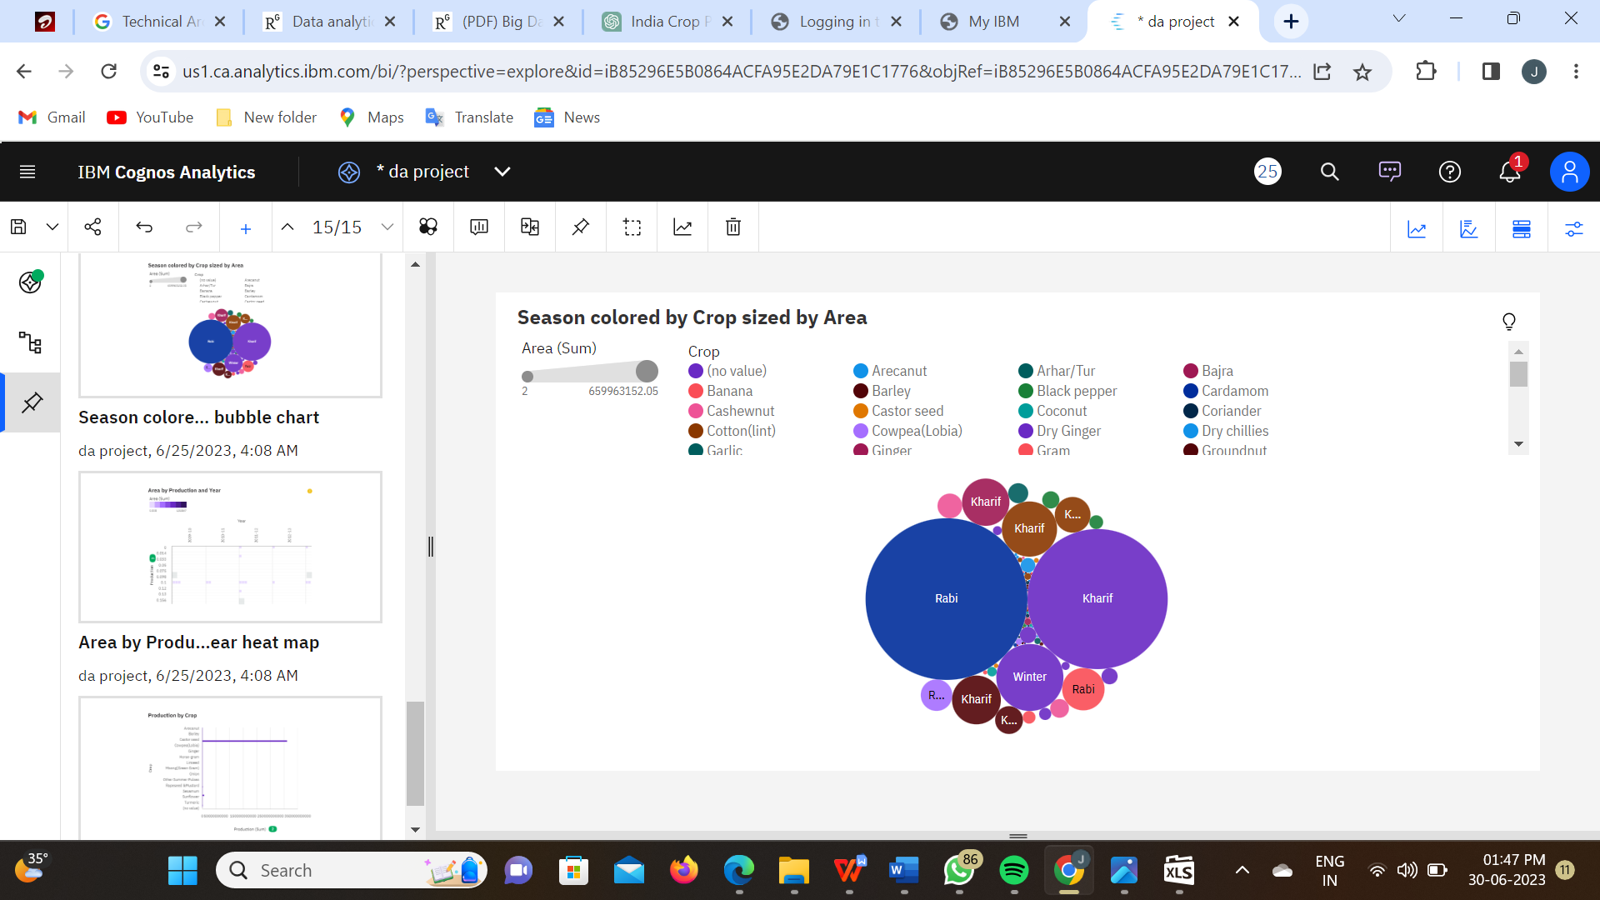

**Link for Explanation –**

[**https://drive.google.com/file/d/1G-zdHcGEDUpbBCvqCuivGQ2xTeyPdVBR/view?usp=sharing**](https://drive.google.com/file/d/1G-zdHcGEDUpbBCvqCuivGQ2xTeyPdVBR/view?usp=sharing)

**COLUMN CHART:**

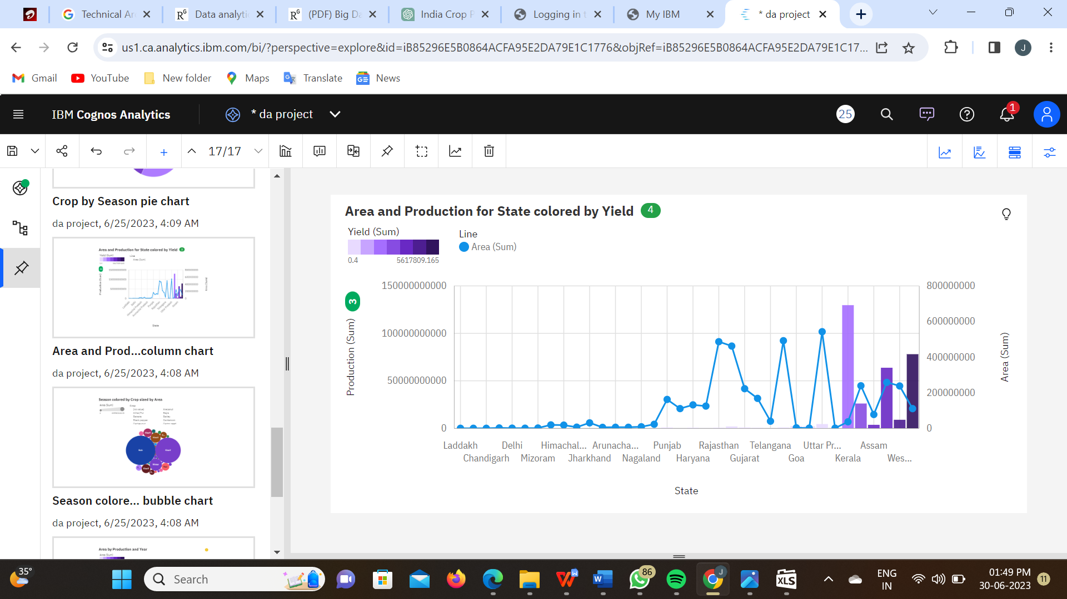

**Link for Explanation –**

[**https://drive.google.com/file/d/1TeMhz6SDLu5AhLm4oWCBByFPm7Ut_QNO/view?usp=sharing**](https://drive.google.com/file/d/1TeMhz6SDLu5AhLm4oWCBByFPm7Ut_QNO/view?usp=sharing)

**PIE CHART:**

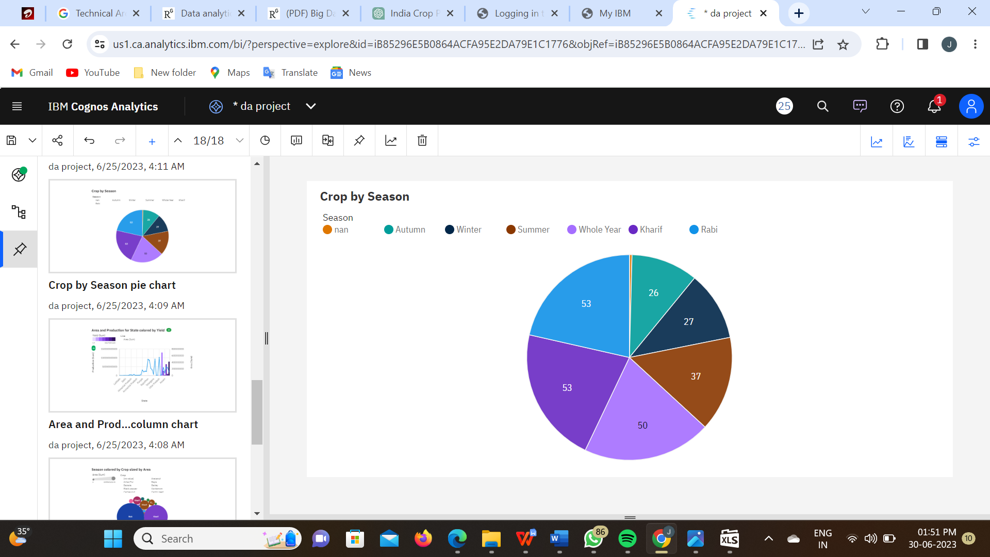

**Link for Explanation –**

[**https://drive.google.com/file/d/1p3vWwrU75aGoE9kNqNT6uhf1fLT5dtU4/view?usp=sharing**](https://drive.google.com/file/d/1p3vWwrU75aGoE9kNqNT6uhf1fLT5dtU4/view?usp=sharing)

**REGIONS CHART:**

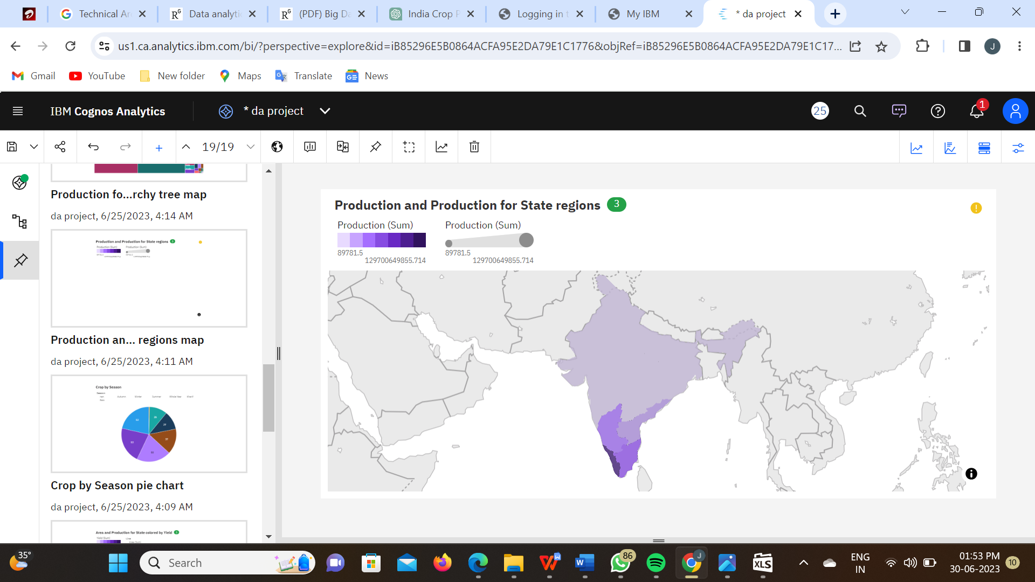

**Link for Explanation –**

[**https://drive.google.com/file/d/1v7WTFB1kk6EiyMkR5sNQIho6sjXpEr2x/view?usp=sharing**](https://drive.google.com/file/d/1v7WTFB1kk6EiyMkR5sNQIho6sjXpEr2x/view?usp=sharing)

**TREE CHART:**

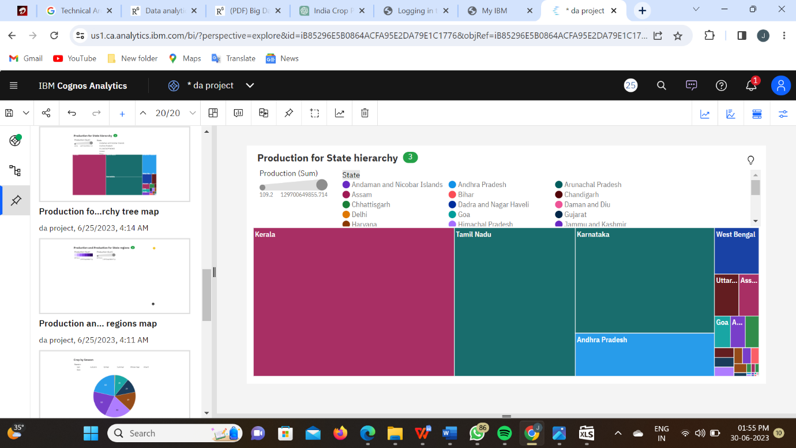

**Link for Explanation –**

[**https://drive.google.com/file/d/11kZqhxNmfNNiw7TGK7BgWb1mgyWTHx-f/view?usp=sharing**](https://drive.google.com/file/d/11kZqhxNmfNNiw7TGK7BgWb1mgyWTHx-f/view?usp=sharing)

**HEAT CHART:**

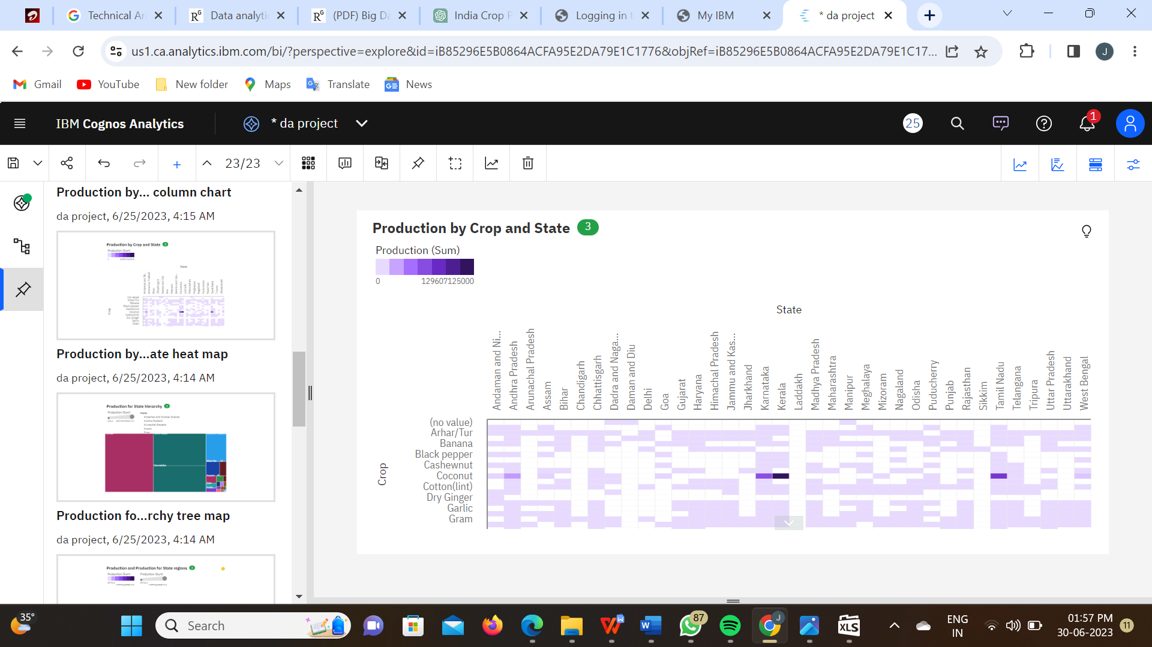

**Link for Explanation –**

[**https://drive.google.com/file/d/1z7petnEPeS1XVuQ-yttttcfjcZ5jp1bJ/view?usp=sharing**](https://drive.google.com/file/d/1z7petnEPeS1XVuQ-yttttcfjcZ5jp1bJ/view?usp=sharing)

**STACKED COLUMN CHART:**

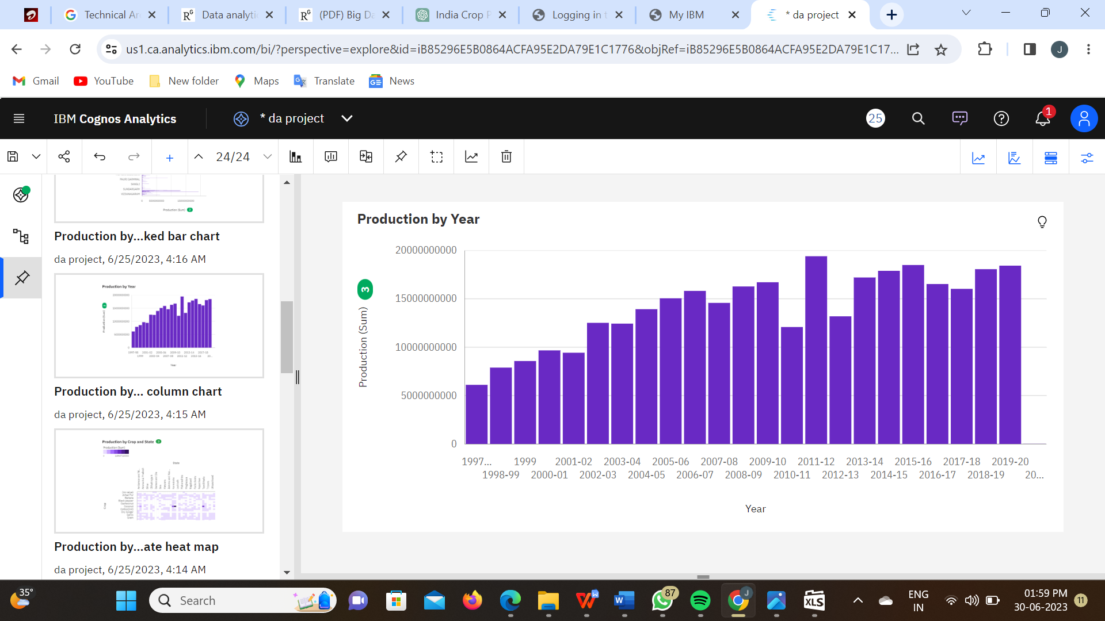

**Link for Explanation –**

[**https://drive.google.com/file/d/1voqeOz7GESTyCmR_QiniSWoj3CS-6wE6/view?usp=sharing**](https://drive.google.com/file/d/1voqeOz7GESTyCmR_QiniSWoj3CS-6wE6/view?usp=sharing)

**STACKED BAR CHART:**

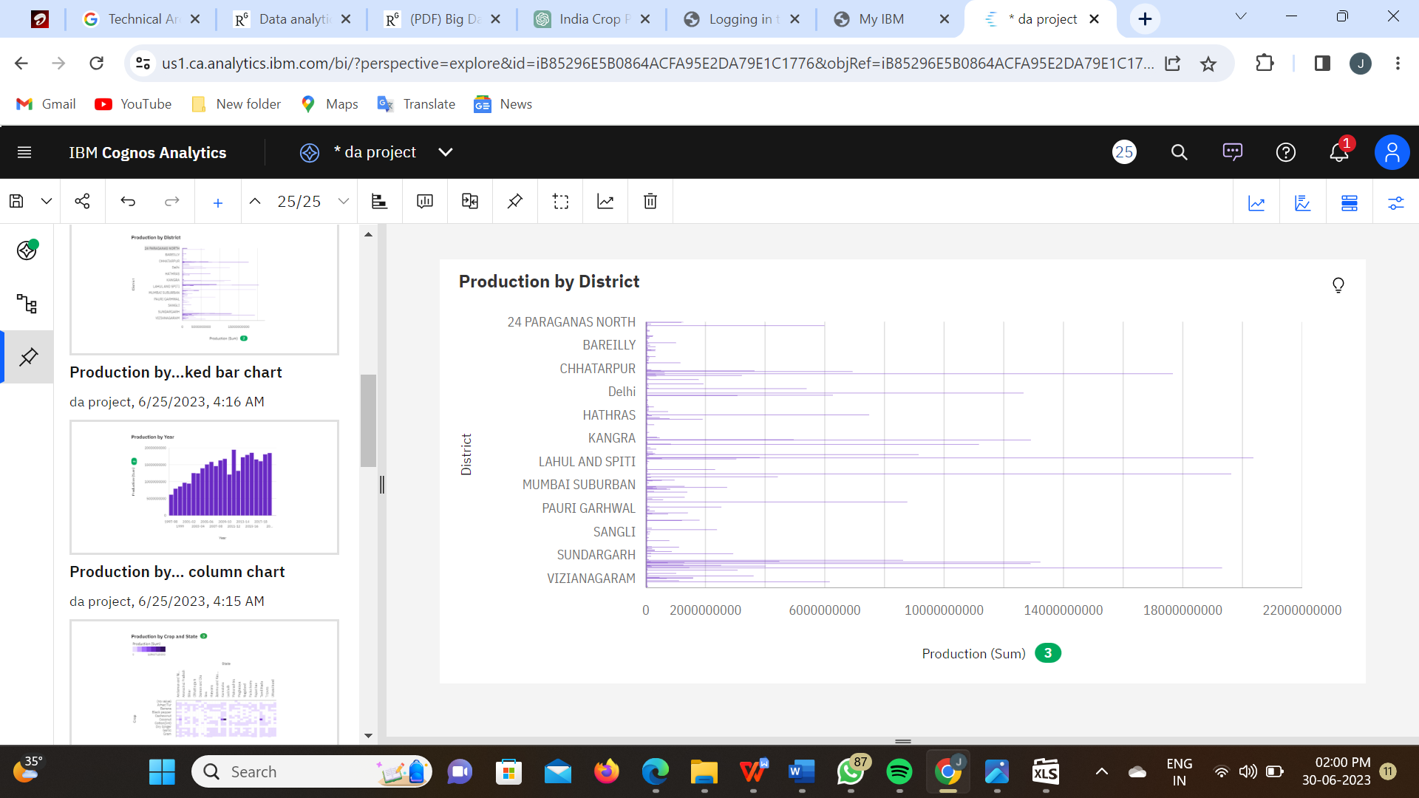

**Link for Explanation –**

[**https://drive.google.com/file/d/1QNvh6fQ_zfHx8ej0a8YgBUzRHF3pBO_a/view?usp=sharing**](https://drive.google.com/file/d/1QNvh6fQ_zfHx8ej0a8YgBUzRHF3pBO_a/view?usp=sharing)

**WORD CLOUD:**

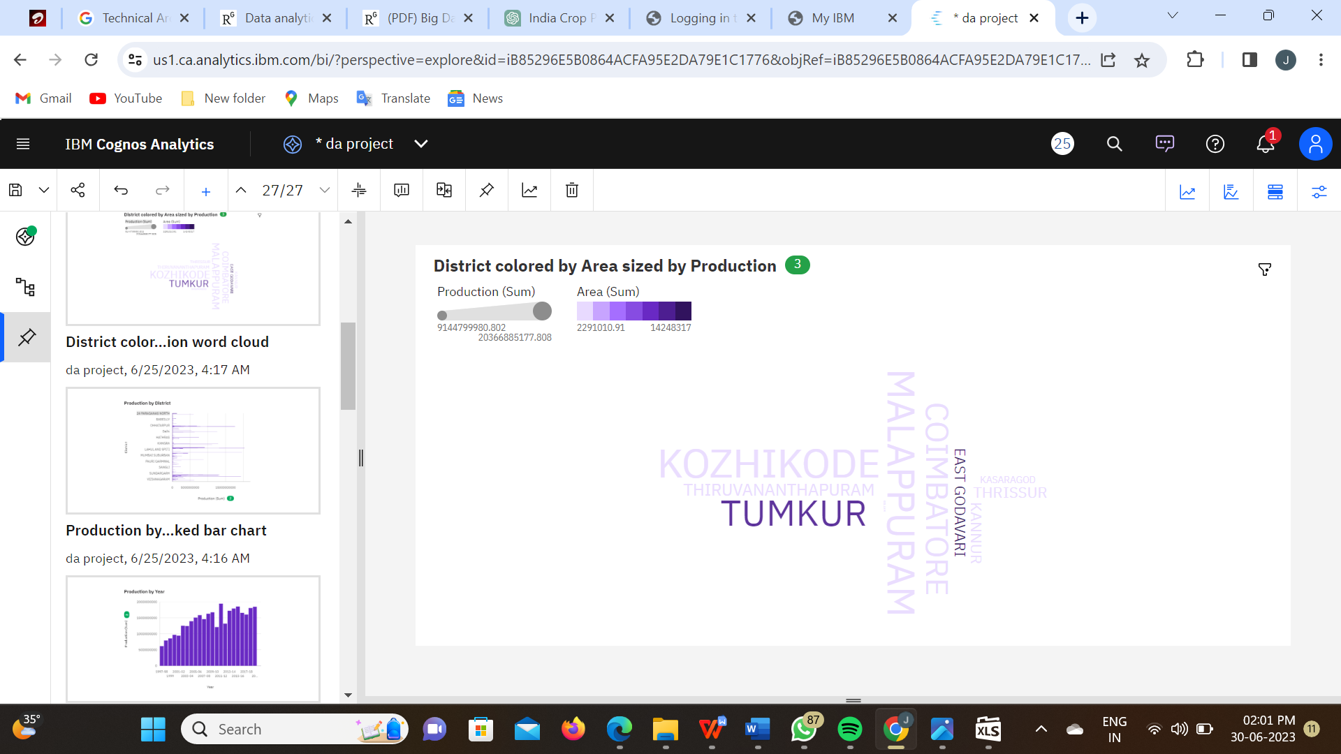

**Link for Explanation –**

[**https://drive.google.com/file/d/1H349aENWBG9xybWh6UOAY5xsZvXJX1If/view?usp=sharing**](https://drive.google.com/file/d/1H349aENWBG9xybWh6UOAY5xsZvXJX1If/view?usp=sharing)

**KPI CHART:**

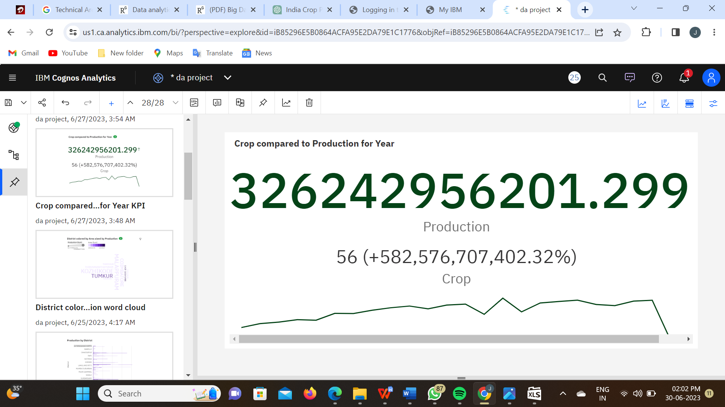

**Link for Explanation –**

[**https://drive.google.com/file/d/1Hn05xP4yAL3fvcNqSkxks4WAYimzqv_9/view?usp=sharing**](https://drive.google.com/file/d/1Hn05xP4yAL3fvcNqSkxks4WAYimzqv_9/view?usp=sharing)

**TABLE:**

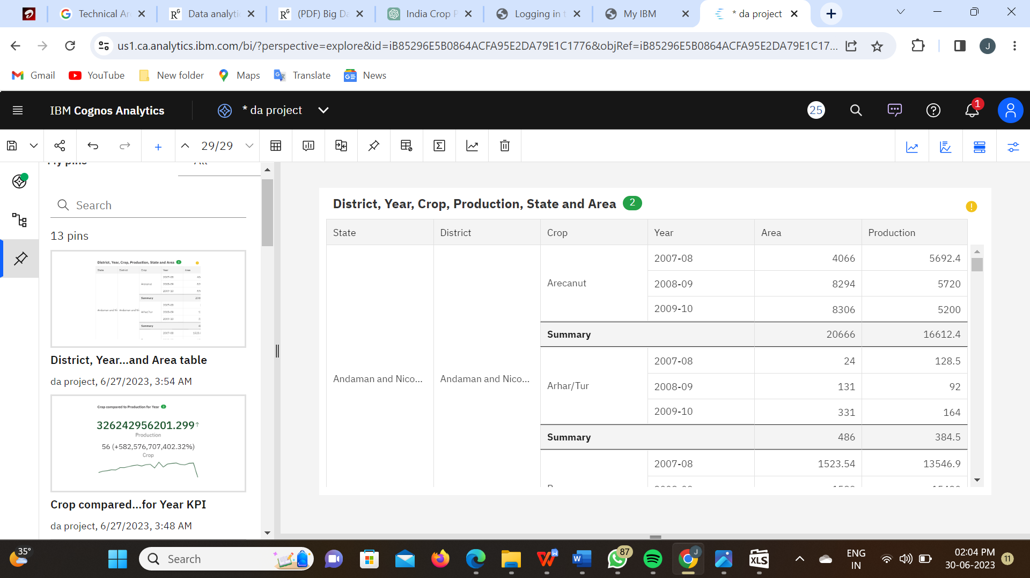

**Link for Explanation –**

[**https://drive.google.com/file/d/1RpJ3lB6C0rAdfw17ZTj4CqLbFmPqXZUO/view?usp=sharing**](https://drive.google.com/file/d/1RpJ3lB6C0rAdfw17ZTj4CqLbFmPqXZUO/view?usp=sharing)

**DASHBOARD:**

A dashboard is a graphical user interface (GUI) that displays information and data in an organized, easy-to-read format. Dashboards are often used to provide real-time monitoring and analysis of data, and are typically designed for a specific purpose or use case. Dashboards can be used in a variety of settings, such as business, finance, manufacturing, healthcare, and many other industries. They can be used to track key performance indicators (KPIs), monitor performance metrics, and display data in the form of charts, graphs, and tables.

The responsiveness and design of a dashboard for The Tableau HR Scorecard: Measuring Success in Talent Management is crucial to ensure that the information is easily understandable and actionable. Key considerations for designing a responsive and effective dashboard include user-centered design, clear and concise information, interactivity, data-driven approach, accessibility, customization, and security. The goal is to create a dashboard that is user-friendly, interactive, and data-driven, providing actionable insights to analyze vehicle collisions.

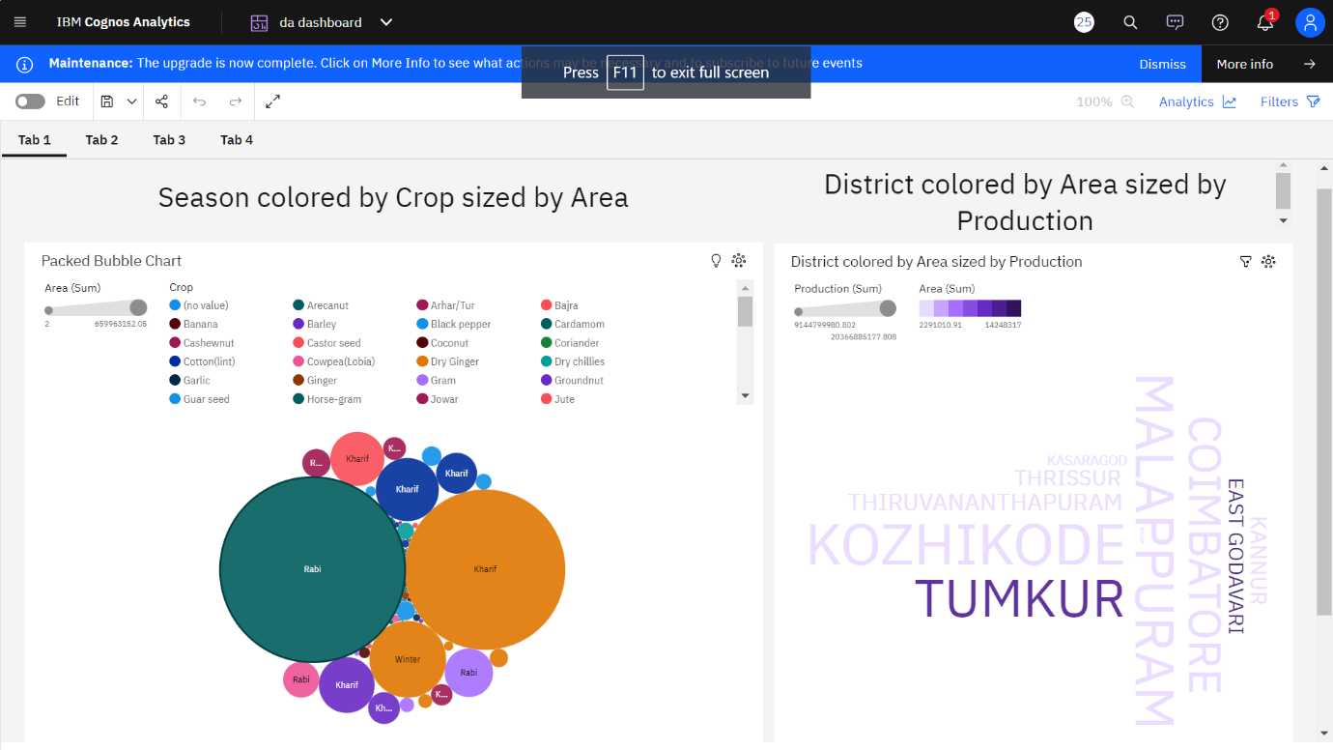

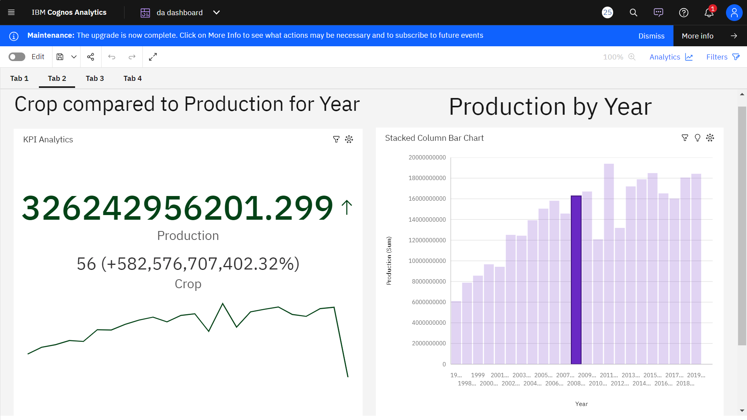

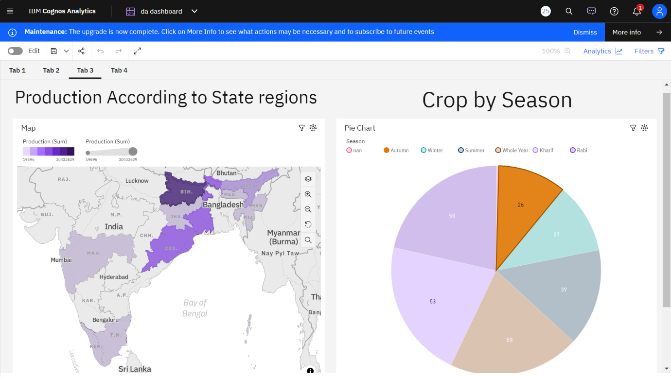

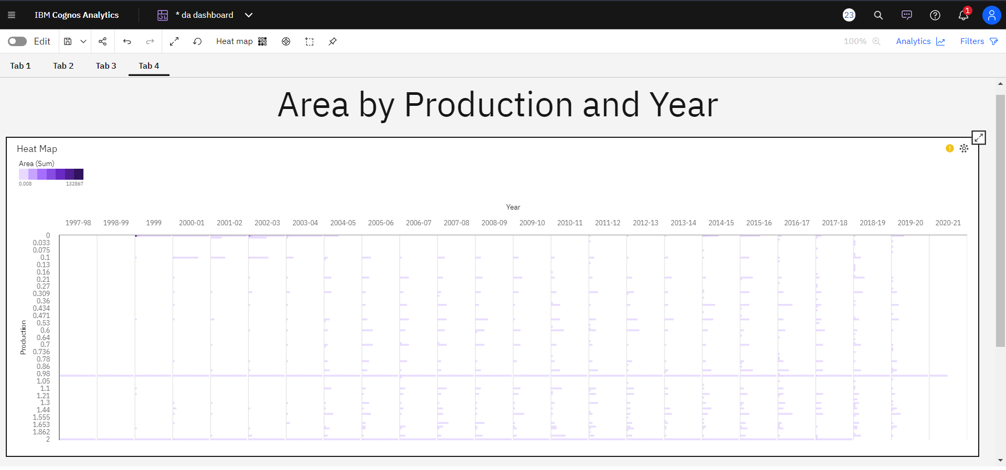

**Link for Explanation –**

[**https://drive.google.com/file/d/1apDzPcrLBQlxqoSFGZUCUabZPx4CRxya/view?usp=sharing**](https://drive.google.com/file/d/1apDzPcrLBQlxqoSFGZUCUabZPx4CRxya/view?usp=sharing)

**Storyline:**

A data story is a way of presenting data and analysis in a narrative format, with the goal of making the information more engaging and easier to understand. A data story typically includes a clear introduction that sets the stage and explains the context for the data, a body that presents the data and analysis in a logical and systematic way, and a conclusion that summarizes the key findings and highlights their implications. Data stories can be told using a variety of mediums, such as reports, presentations, interactive visualizations, and videos.

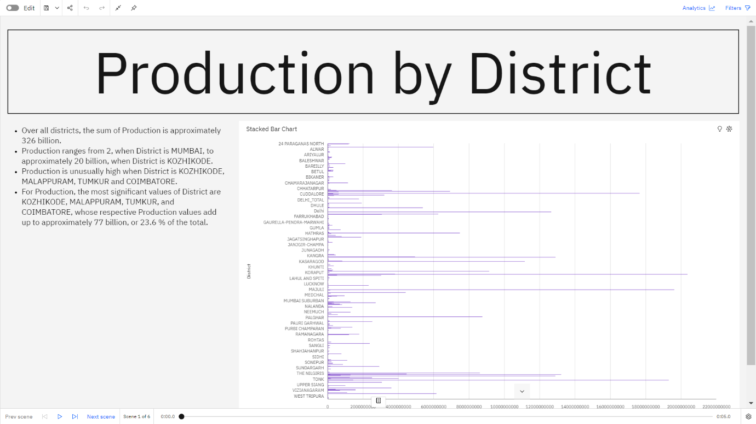

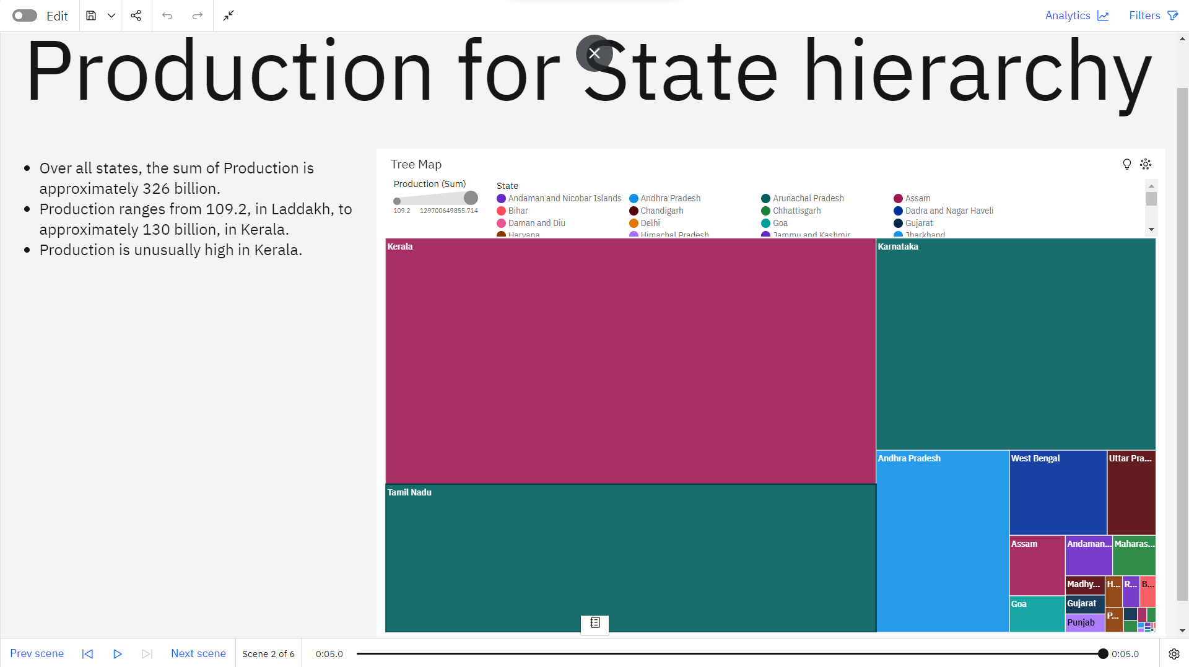

**Link for Explanation –**

[**https://drive.google.com/file/d/1j_IRSs43J6zkE-XuWYxWCH3TZPWXSLRd/view?usp=sharing**](https://drive.google.com/file/d/1j_IRSs43J6zkE-XuWYxWCH3TZPWXSLRd/view?usp=sharing)

**Utilization Of Data Filters:**

Data filters play a crucial role in HR analysis in Tableau by allowing users to narrow down and focus on specific subsets of data. They help in exploring and analyzing data from various perspectives, uncovering patterns, and gaining insights

Below we have applied the filter for only Life Science Medical and Marketing and we see that the other visualisations are changing accordingly

**No Of Calculation Fields:**

Calculation fields in Tableau allow users to create custom calculations using existing data in their datasets. These calculations can involve basic arithmetic operations, aggregations, logical conditions, string manipulations, and more. Calculation fields provide flexibility and enable users to derive new insights or perform complex calculations on their data

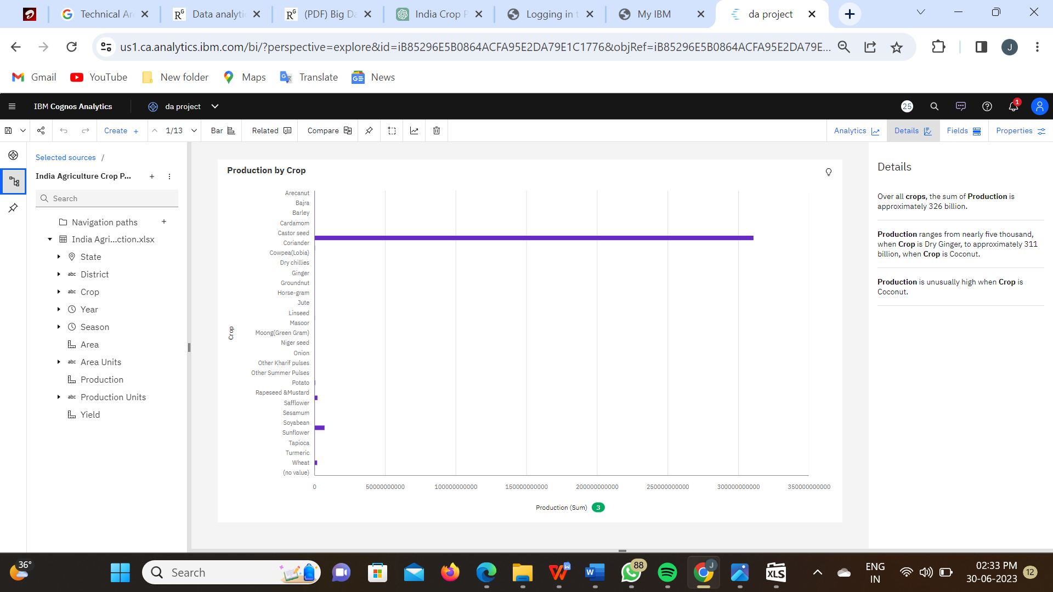

**Web Integration:**

Here is a summary of the steps we followed to integrate the modified Bootstrap template with the Tableau HR Scorecard dashboard and visualizations using Flask:

1) Selected a Bootstrap Template: We carefully chose a Bootstrap template that suited the design and layout requirements of the Tableau HR Scorecard project.

2) Modified the Template: We customized the selected Bootstrap template to align with the branding and visual style of our HR Scorecard project. We made changes to colors, typography, layout, and other elements to create a cohesive look and feel.

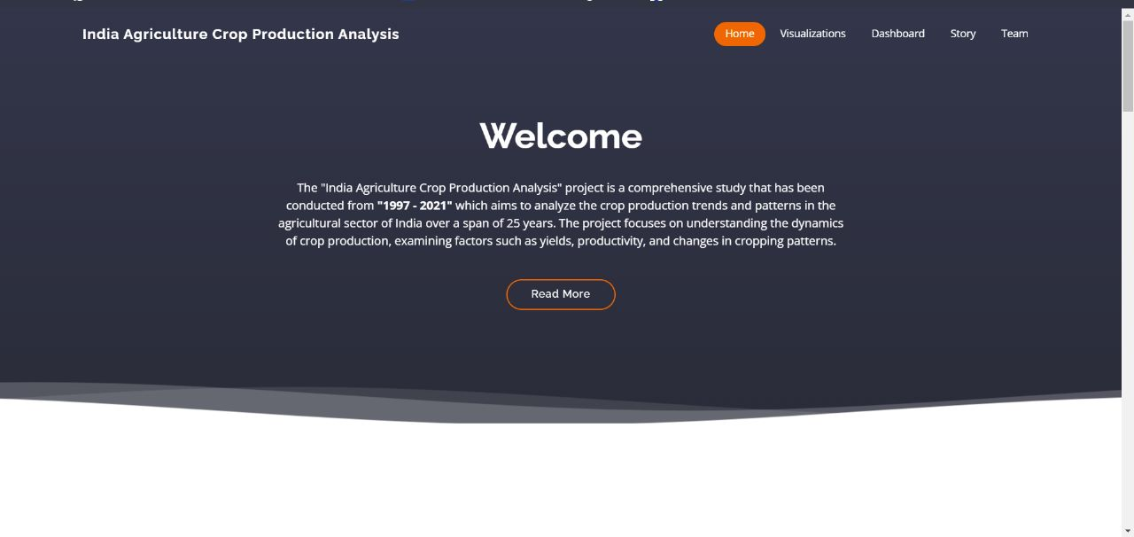

3) Built Flask Application Structure: We set up the basic file structure for our Flask application, including directories for static assets (CSS, JavaScript, images) and templates.

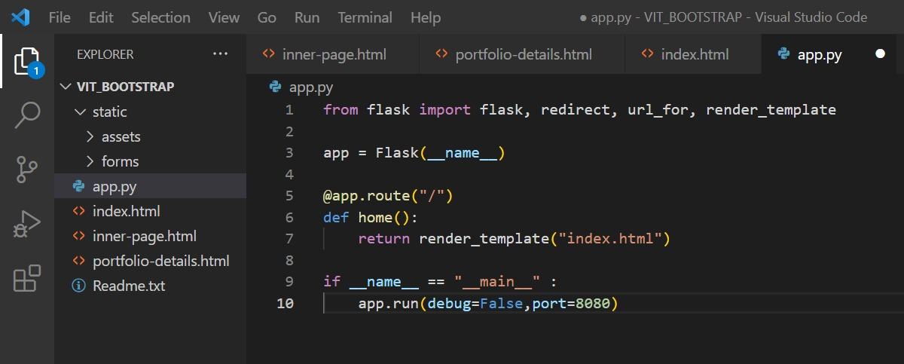

4) Defined Flask Routes and Views: We defined Flask routes and views to handle incoming HTTP requests and render the appropriate templates. We created separate routes for the dashboard, story, and individual visualizations.



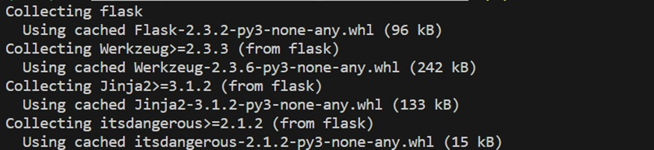

5) Managed Static Assets: We placed our modified Bootstrap template files, custom CSS, JavaScript, and other static assets in the appropriate directories within our Flask project's structure. We linked these assets to the HTML templates for proper styling and interactivity.

6)Embedded Tableau Visualizations: We followed Tableau's documentation to embed Tableau visualizations into our web application using HTML and JavaScript. We customized the embed code to fit within our Flask templates and ensure proper functionality.

7)Implemented Navigation and Interactivity: We enhanced the user experience by implementing navigation menus, buttons, and interactive features in our Flask application. We ensured smooth transitions between different sections of the HR Scorecard, such as switching between the dashboard, story, and visualizations.

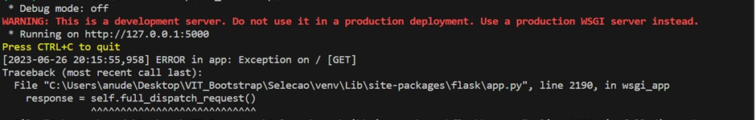

8)Tested and Debugged: We thoroughly tested our Flask application locally, identifying and addressing any errors or issues that arose during integration. We used Flask's development server and monitored the console for error messages and warnings.

9) Deployed the Application: Once satisfied with the functionality and design, we deployed our integrated web application to a production server or hosting platform. We followed deployment best practices for Flask applications, including configuring appropriate server settings and ensuring the security of sensitive information.

Overall, the integration of Tableau HR Scorecard dashboard and visualizations into our website, leveraging the capabilities of Bootstrap, transformed our HR analytics into an engaging and user-friendly web experience. The result is a visually compelling and data-rich platform that empowers organizations to measure success in talent management effectively.

